Guidelines for Maintaining the Historic Roll
The Historic Roll is an historical record of the membership of the congregation. Basic rules:
- Names should be entered chronologically as members are received into the congregation
- Each new member is given a unique, sequential number in the Roll
- When a member dies, leaves the congregation, or is removed by action of the Session/Council/Board, that information is entered in the appropriate column
- No name is ever crossed out or erased
Rules for Each Column
Check | This column is traditionally used to mark those members who have been removed. This practice facilitates a quick scan of the page.
Roll No. | This is the permanent number assigned to each member when they are entered into the Historic Roll. For each new entry, use the next number in sequence.
Name | Use upper and lower case letters (not all capitals) in order to clearly indicate which letters of a name are to be capitalized.  Print the surname first, followed by a comma, then the forenames and/or initials.  Do not use the titles Mr., Mrs., Ms., Miss, Dr., etc.  e.g. de Vil, Cruella ()  DE VIL, CRUELLA ()  de Vil, Dr. Cruella ()  de Vil, Mrs. Damian ()
Reference | This column is intended for the member’s address at the time of joining the congregation. It is never updated, even if a person moves.
Received | Enter the date on which the person became a member of the congregation.
How? | Enter the means by which the person became a member using one of the following abbreviations:  T by certificate of Transfer from another congregation  R by Reaffirmation of faith. This is used for a person who has already been baptized and confirmed, but whose membership has lapsed due to inactivity, and therefore, no certificate of transfer can be issued.  C by Confirmation (sometimes referred to as Profession of Faith). This includes adult baptism.  If a different method of reception is to be documented, choose a logical abbreviation and explain it in a footnote on that page.
From where certified | This column is used for a transfer of membership, to indicate the name of the congregation from which the person is transferring.
Removed | Enter the date on which the person ceased to be a member of the congregation.
How? | Enter the means by which the person’s membership terminated, using one of the following abbreviations:  T by certificate of Transfer from this congregation  D by the Death of the individual  S by action of the Session (or B for Board, C for Council)  The governing body is responsible for revising the historic roll at least annually. Names of inactive members who have been absent for too long in the opinion of the governing body (perhaps three years) should be noted as removed. However, an effort should be made to contact the individuals to be removed, as a courtesy.  Document in the Session/Board/Council minutes all decisions to remove a name from the Roll.  If a different method of removal is to be documented, choose a logical abbreviation and explain it in a footnote on that page.
Footnotes | If necessary, leave a few lines at the bottom of each page for the purpose of entering footnotes. To enter a footnote, place an asterisk at the end of the name. In the footnote space, place an asterisk followed by the number of the entry to which the footnote refers, then write the footnote. Footnotes are used to provide explanations for irregularities.  e.g. * 104 Date of death unknown  * 127 Married name: Bell  * 176 “Affirmation”: Affirming a dual commitment: Roman Catholic and United Church

Historic Roll – Frequently Asked Questions
What is the historic roll?
The historic roll is a complete record of the names of all persons who have been confirmed members of your local congregation throughout its history.
What physical format does the historic roll take?
The historic roll is usually a handwritten listing of names, recorded in a bound book or ledger. If your church was organized many years ago, a complete listing of all persons who had ever been confirmed members would likely encompass several books. UCRD (United Church Resource Distribution) sells bound historic roll volumes with ledger paper, which you can purchase online.
How can we include the names of all persons who have ever been members? Our records don't go back that far.
Including all names is the ideal; many congregations can't do this because a formal recording system was not followed from the founding of the congregation, or because records have been lost. An historic roll of members can be started at any time by recording all those who are currently members of the church. The historic roll is maintained by adding the names of all new members as they join the congregation.
What does "member" mean?
When a person is baptized in your congregation, usually as a child, the person becomes a baptized member of the church universal. A United Church person who affirms as a teenager or adult through a public profession of their faith their baptismal vows, becomes a confirmed member of your congregation and thus of The United Church of Canada.
Is the historic roll the same as the current membership roll?
No, and one should not confuse the two. The names that appear on your current membership roll will include only those names from your historic roll that have no indication of removal recorded beside them. The two rolls are separate records and should not be used interchangeably.
Who is responsible for maintaining the historic roll?
Membership records have traditionally been under the jurisdiction of the Session. In earlier years it was customary for congregations to have one person in charge, filling the position of Roll Clerk. Most congregations have now changed to a Board or Council structure, many of which no longer have a Roll Clerk as a distinct position. Maintenance of membership records now tends to be supervised either by the administrative person in the church office, or by the minister.
Can we keep the historic roll in an Excel spreadsheet or database?
Always keep the roll in hardcopy form; electronic versions (Word, Excel) are not acceptable.
Isn’t it easier to find a name if we organize the roll alphabetically by surname?
An alphabetical roll is too difficult to maintain neatly over time. To facilitate finding a name, use an alphabetic index arranged by surname, giving the corresponding Roll Number.
Sample Roll Entries (partial) Sample Alphabetic Index
Name | Roll No.
Burns, George | 382
de Vil, Cruella | 2
Diller, Phyllis | 4
Flintstone, Fred | 3
Mouse, Minnie | 1
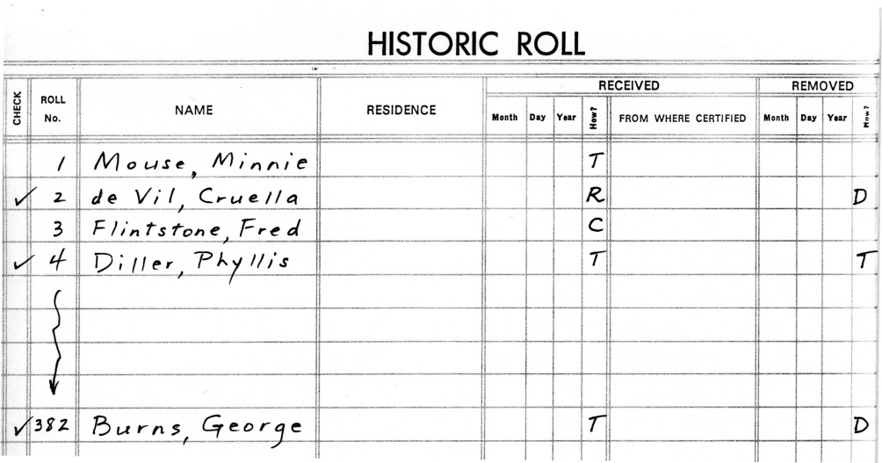
When removing someone from the roll by death, should we use the date that they died, the date that the name is recorded in the Session minutes, or the date we learned of their death?
When a member dies, the date of death is the proper date to put in the Removed column. Death automatically removes them from active membership. However, their name is never actually removed from the Roll.
What if the date of death is unknown?
If that date is unknown, record it as the date that the Session removed the name. Include a footnote, if possible, e.g. “Pre-deceased”, so that the date of removal in this case isn’t mistaken for the death date.
We regularly do membership transfers both to and from other United Church congregations. But if someone is coming from or going to another denomination, is it still a transfer?
Yes, it is a transfer within the Christian church to or from another denomination.
If a member becomes a clergyperson, their membership will rest with their Presbytery until they retire. How is that handled on the historic roll?
Note in the Roll that the individual has been ordained/commissioned and transferred to Presbytery roll.
When a member is transferred out and at a later date transfers back in, do they get a new roll number or do they keep their original roll number?
They get a new roll number, mainly because there will be no room to fill out the new information in the original spot. Also, the new number itself indicates that the person had left. However, it's important to include a cross-reference between both numbers (in EACH entry) so that the individual's history can be tracked.

