Application for Hybrid Worship Technical Assistance Fund

Community of Faith
Contact Person
Date

Typical Equipment List for Hybrid Worship
Indicate which equipment (or equivalent) has been purchased and submit receipts to qualify for assistance from the fund. See sample setup diagram from Rev. Kent Chown on next page. Please note that these are matching grants to cover 50%-75% of the cost of needed equipment and that the maximum grant is $3,000 per community of faith. Please email completed application forms (along with copies of receipts) to Brian Ruse: bruse@united-church.ca

ITEM | RECOMMENDED MODELS | SUGGESTED PRICE RANGE | QTY | COST/UNIT | TOTAL
Laptop | Acer Aspire 5 A515-56-7699, i7-1165G7 | $900 to $1100 | 1
 | Acer Aspire 5 A515-56T-53QF, i5-1135G7
Monitors | For Zoom control computer | $175 to 850 | 1
 | For congregation (75 inch) |  | 1
 | For choir (50 inch) |  | 1
Microphones | Shure SM58 | $175 to 425 | 1
 | Shure MV 7
Speakers | Wireless Bose 2 | $175 | 1
Camera | Tenveo VHD102U | Video Conference | $550 | 1
 | Tripod 56 in | $60 | 1
Cables/hubs | USB - XLR female adaptor cable  (analog mixer to USB on PC for sound) | $25 | 1
 | USB cable extenders (max 100ft) 25 ft | $20 | 1
 | USB Hub, Aiibe 6 Ports Super High Speed, USB 3.0 Hub Splitter + 24W Power Adapter + USB 3.0 Cable | $30 | 1
 | Ethernet cable cat5 or cat6? (max 100 ft) | $20 | 1
 | Digiflex NXX-50 Pro mic cables - 50 ft | $50 | 4
 | 8-Port 10/100/1000Mbps Desktop Unmanaged Switch - TP-LINK® (to expand internet modem ports) | $50 | 1
Sound mixer | Mackie ProFX 12 ch | $400 | 1
Other
TOTAL
(excluding tax and installation)

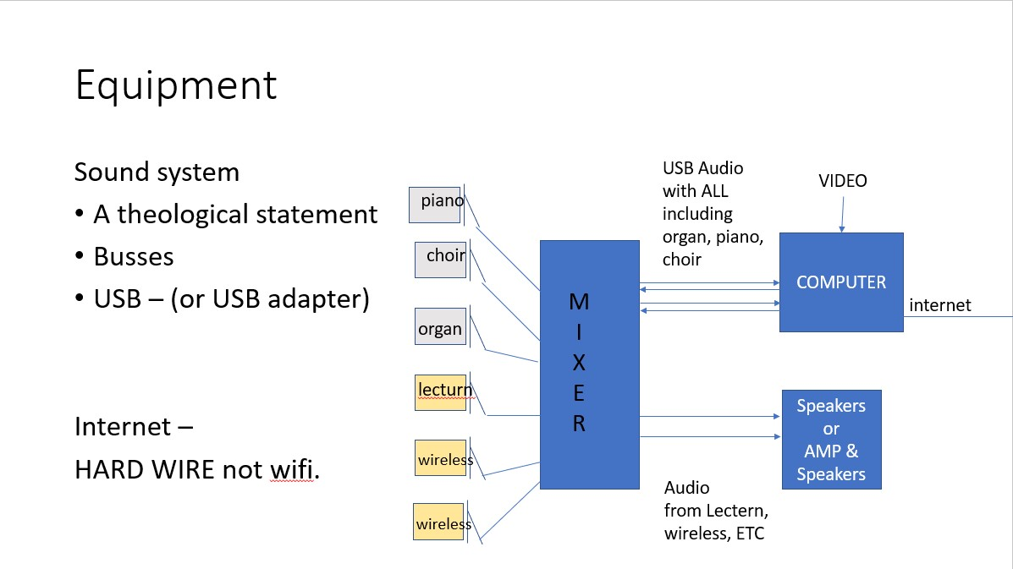
Diagram courtesy of Rev. Kent Chown

For internal use only
DATE RECEIVED
ADDITIONAL COMMENTS
AMOUNT APPROVED | $
APPROVED BY
DATE OF PAYMENT

