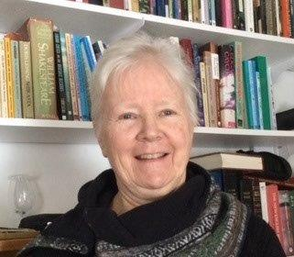
Lee Ann Hogle – my ministry
The vocation of ministry came to me later in life when I was struggling with life’s purpose and meaning. Exploring those themes in the public arena of ministry has been daunting but also very rewarding. As I understand happens with many of my colleagues, during my five years of ministry-based studies and my nine years as a fulltime minister, my reading became more and more focused on subjects directly related to church life, less and less time was available for reading as a leisure activity or reading with a wider scope. It is only now, with time and energy to spare that I can look back and reflect on the truly counter-cultural choice it is to be a Christian in the year 2023. I have just finished reading Humankind by Rutger Bregman, in which the author promotes many of the values and life lessons Jesus offered us, with very little reference to Christianity, and most of that falling into the category of the negative aspects of organized religion. To be sure whenever two or three are gathered we have the potential for disagreement and uncharitable behaviour, but as Jesus teaches we also have the potential to be so much more than the sum of our parts when it comes to treating one another with compassion and generosity. From the opening days of discernment eighteen years ago to the closing goodbyes in June 2022 I have had the great good fortune to be nurtured, supported, counselled and encouraged on this Christian path we call The Way. I have also had the privilege to do the same for others. It has been an honour and has most certainly given my life purpose and meaning.
As the retirement years stretch out before me I remain in the ‘recharging-the-batteries’ mode but continue to be enticed by all the opportunities the retired life offers. None of us can predict our personal futures nor that of our churches, but the more I have embraced my membership in this church family- locally, and then regionally, the more I have been embraced. That is surely blessings worth celebrating.

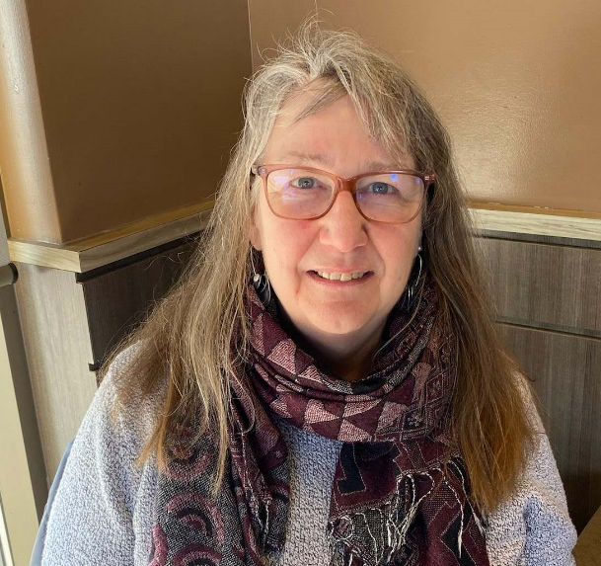
Rev. Rosemary Lambie is a child of the United Church, baptized at Westmount Park (Montreal), confirmed at St. James (Ottawa), she was a candidate for ministry from St. Andrew's-Norwood and ordained in 1982 by Montreal and Ottawa Conference after studying at the United Theological College in Montreal, with an internship in Saskatchewan.
Settled into the Montreal Presbytery Group Ministry (five congregations along the south shore of Montreal), Rosemary moved to a team ministry at St. Andrew's, Chateauguay in 1987, and then to be Minister of Congregational Development for the Montreal Presbytery in 2000, known for travelling with a guitar in one hand and coffee mug in the other.
Rosemary began as the Executive Secretary for Montreal and Ottawa Conference in December 2005, for an area that included about 235 ministry sites in Quebec and eastern Ontario. Working included supervision of staff in offices in Montreal and Ottawa, and oversight of five presbyteries; the “bumblebee” role, sharing the good news and successful ideas from one presbytery to another! Some referred to her as Mère-Poule / Mother Hen!
In 2018, as the church transitioned, she took on the responsibility of all the communities of faith in the former Bay of Quinte Conference, plus a few from Toronto, expanding oversite to about 450 ministry sites in three new Regional Councils, complete with 3 staff teams and 3 sets of volunteers each charged with creating something new to re-vision the church.
Attendance at 8 General Council meetings (2 as a Commission, 6 as staff) and TRC gatherings privileged her with opportunities to appreciate the vastness of Canada.
Life-altering experiences included two trips to the Philippines and a visit to Australia. The follow-up was many presentations, encouraging both monetary and emotional support of our global partner churches.
Her distant past includes lifeguarding on the waterfront in summer camps, a BA in Theatre and teaching in elementary schools in Montreal, all of which have proved to be good training for her calling into ministry.
Rosemary is the proud mother of four sons and partners and a blessed-in-abundance “Lola” to 10 grandchildren born between 2012 and 2022.
Retirement after 40 years of ministry will be for family, aqua fitness, walking, biking, gardening, camping, handwork, reading for pleasure, theatre opportunities, and entertaining at home…. And whatever else GOD encourages.

